# S2S Global: New Supplier Onboarding Manual

# Table of Contents

**Quality Assurance** 2

❖ Final Sample Requirements 2

❖ Finished Product Inspections 2

❖ Regulatory Labeling 2

❖ Unique Device Identification (UDI) 3

❖ Product Compliance 3

❖ FDA Registration/Device Listing Place Holder 4

❖ Audit Placeholder 4

**Sourcing** 5

❖ Contract Agreement 5

❖ Chargeback Policy 5

❖ Supplier Questionnaire 6

❖ Regulatory Information Form (RIF) 6

❖ Cost Template 6

**Logistics** 7

❖ Case/Carton Requirements 7

❖ Case/Carton Marking Requirements 7

❖ Pallet Height Requirements 7

❖ Yusen Logistics 7

# Quality Assurance

## **Final Sample Requirements**

Final approval samples are supplier samples that meet the requirements for production approval. The samples should be submitted for approval by Product Development and the Clinical team. The samples will be reviewed for visual and dimensional conformance to the product specification and expected function. Approval of the final sample does not alleviate the supplier of their responsibility to comply with the requirements and regulations that apply to the item.

Once final samples are approved, no changes are permitted. Approval from S2S Global is required prior to any changes after the final samples have been received. Three sets of the final samples are required: Product Development, Quality Assurance, and Final Inspection Reference samples. Final samples are retained for one year.

## **Finished Product Inspections**

Finished product inspections are performed on products manufactured for S2S Global. A finished product inspection can be performed at the contract manufacturer’s facility or at S2S Global US based warehousing facilities. The finished product inspections can be performed by a S2S Global employee, an authorized representative of S2S Global, or by a third-party inspection company. Frequency of inspection is determined by the product status or type.

Each device or product has unique inspection procedures. A category specific inspection template is used for the finished product inspection. The template includes the inspection plan procedure, classification of defects, and detailed guidance for the inspection.

## **Regulatory Labeling**

The device and product packaging must meet all regulatory requirements. This includes, but is not limited to, product identification, country of origin, Unique Device Identification (UDI), and symbols (e.g. storage conditions, sterile, not made of natural rubber latex). The supplier should follow the artwork guidelines provided by S2S Global for each item.

## **Unique Device Identification (UDI)**

As of September 24, 2020, all medical devices distributed in the United States must bear the labeling marks to meet the Unique Device Identification (UDI) requirements. Class III and Class II devices must include the full required marking on all levels of packaging. Class I devices are not required to bear the production identifier marks. All devices are registered in the GUDID database by the S2S Global Quality Department.

[Unique Device Identification System (UDI System) | FDA](https://www.fda.gov/medical-devices/device-advice-comprehensive-regulatory-assistance/unique-device-identification-system-udi-system)

## **Product Compliance**

All devices and products manufactured on behalf of SVS LLC, dba S2S Global, must be compliant for all member locations. All federal and state level regulations must be met. All devices and products must submit test reports to S2S Global to support the expected performance and featured claims of the device or product. The exact list of testing requirements is product specific and is shared with the supplier at the time of onboarding the device or product.

Proposition 65 warning labels are not permitted without expressed permission. Products are expected to meet compliance without warning labels. A required statement on supplier letterhead is collected during the onboarding process and should state that the product and packaging is compliant, and/or that the product and packaging is free of chemicals on the published Proposition 65 list. It is the supplier’s responsibility to ensure compliance to Proposition 65 to indemnify and defend S2S Global if the compliance is challenged.

[Proposition 65 | OEHHA (ca.gov)](https://oehha.ca.gov/proposition-65)

## **FDA Registration & Device Listing**

All devices and products manufactured on behalf of SVS LLC, dba S2S Global must be registered with the FDA.

**Medical** **Devices**

Owners or operators of places of business (also called establishments or facilities) that are involved in the production and distribution of medical devices intended for use in the United States (U.S.) are required to register annually with the FDA. This process is known as establishment registration.

[Device Registration and Listing](https://www.fda.gov/medical-device-registration-and-listing)

**Cosmetics**

The Voluntary Cosmetic Registration Program (VCRP) is an FDA post-market reporting system for use by manufacturers, packers, and distributors of cosmetic products that are in commercial distribution in the United States.

[Voluntary Cosmetic Registration Program](https://www.fda.gov/registration-program)

## **Audit**

Supplier is required to provide S2S Global limited access to conduct periodic audits and inspections of supplier location(s) involved in the manufacture and packaging of S2S Global product. Please see supplier contract section 3.2 for more details.

# Sourcing

## **Contract Agreement**

The S2S Global supplier contract agreement must be signed by both the supplier and S2S Global. Points included, but not limited to, are Distribution Rights, Manufacturer Order Delivery, Inspections, Pricing, Payment Terms, Indemnification, Confidential Information, Term/Termination, Notices, Force Majeure, Compliance, Chargeback Policy, Specifications. Please reach out to the category Sourcing Manager for supplier contract template.

## **Chargeback Policy & Packing List**

The S2S Global chargeback policy as outlined in below document has been introduced to streamline supplier performance. This program will be used in conjunction with supplier scorecards so that S2S Global can focus on outstanding supplier performance and will conversely provide better visibility into supplier’s challenges with S2S Global’s requirements. S2S Global wants to continue to recognize those suppliers that go above and beyond year after year.



**Example Packing List**

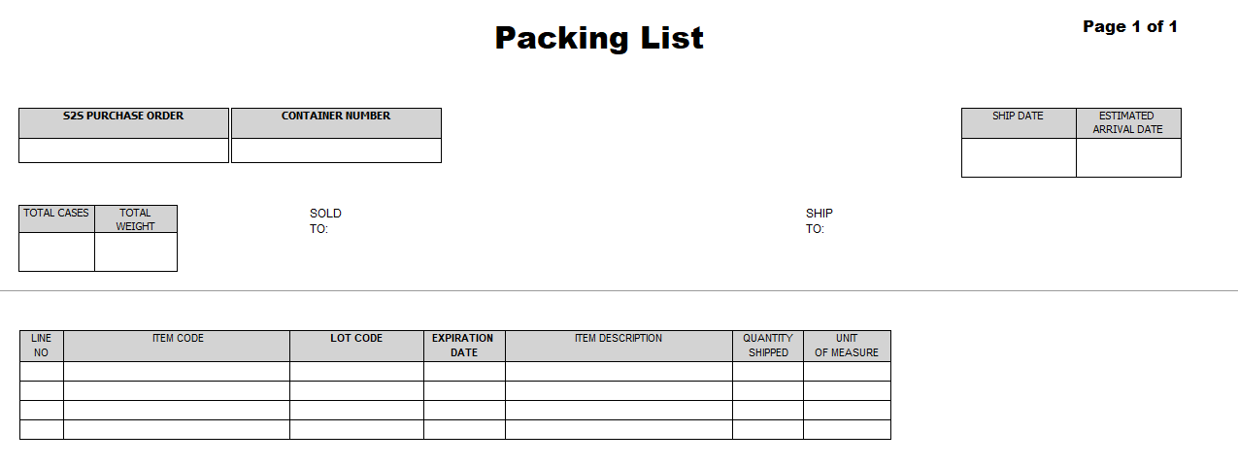

## 

## **Supplier Questionnaire**

The S2S Global supplier questionnaire document below, along with supporting documentation, is required to be completed and signed by the supplier. The purpose is to collect company/factory specific details and information.



## 

## **Regulatory Information Form (RIF)**

The S2S Global regulatory information form is required to be completed and signed by the supplier. The purpose is to collect item specific regulatory details and information.



## 

## **Cost Template**

All costing must be submitted on below cost item setup template.



# Logistics

## **Case/Carton Requirements**

Where possible, use biodegradable and recyclable packing materials. Case/cartons should be securely sealed. Do not band cartons together nor use banding to secure cartons. No bands of straps of any kind are allowed. If cartons are secured with shrink wrap, it must not interfere with the barcode. Shrink wrap is permissible around pallet only (do not shrink wrap individual case/cartons). Case/cartons should have a minimum strength of 32 ETC (edge test crush). Case/cartons must be strong enough to withstand several further reshipments as individual case/cartons throughout the S2S Global supply chain. Do not use excessive packing materials inside the carton (i.e. cardboard, air pillows, inserts, foam pieces) and be environmentally conscious (where possible) of how merchandise is packed. Packing peanuts are not allowed. Cardboard inserts are acceptable.

## **Case/Carton Marking Requirements**

Barcode labels must be attached prior to delivery to S2S Global. Supplier is responsible for ensuring that the barcode is scannable. Each case/carton label must be affixed in such a manner to withstand the normal in-transit wear and tear. Do not apply anything over the barcode label, including clear tape, as this may reduce the ability to scan.

## **Pallet Height Requirements**

Supplier’s pallet height must not exceed eighty (80) inches.

## **Yusen Logistics**

Yusen Logistics is the S2S Global nominated freight forwarder. Purchase orders are booked and transmitted via EDI through the Yusen Logistics portal. The Yusen origin contact list (by country) is included below for reference. Please reach out if a specific country of origin is not listed.

